Traditional server computers, to include pedestal, micro, rack mount, blade, high density/modular, partitionable, SoC

**Minimum Hardware**

<https://docs.microsoft.com/en-us/windows-server/get-started-19/sys-reqs-19>

***Processor:*** x64 processors; 1.4 GHz or faster 64-bit processor or SoC; IoT Core: 400 MHz or faster x86, x64 processor or ARM SoC

Computers that run Windows Server 2016 require a 64-bit 1.4 GHz or faster processor or SoC that meets the following requirements:

* Compatible with the x64 instruction set.
* Supports NX and DEP.
* Supports CMPXCHG16b, LAHF/SAHF, and PrefetchW.
* Supports Second Level Address Translation (EPT or NPT).

***Memory:*** 512 MB; IoT Core: 256 MB available to the OS for devices without display support; 512 MB available to the OS for devices with display support, depending on resolution

Computers that run Windows Server 2016 must include at least 512 MB RAM. The RAM must use ECC or similar technology to prevent single-bit errors from causing system failure.

***Storage***: 60 GB ; IoT Core - 2 GB

Computers that run Windows Server 2016 must include a 60 GB or larger storage device.

***OS:*** Windows Server 2016; 2019

***Networking:*** A Gigabit Ethernet adapter; A network adapter that supports PXE

***Security***

* TPM: 2.0
* Hardware-based and firmware-based TPMs must implement version 2.0 of the TPM specification.
* An EK certificate must either be pre-provisioned to the TPM by the HW vendor or be capable of being retrieved by the device during the first boot experience.
* It must ship with SHA-256 PCR banks and implement PCRs 0 through 23 for SHA-256. Note that it is acceptable to ship TPMs with a single switchable PCR bank that can be utilized for both SHA-1 and SHA-256 measurements.

***UEFI Secure Boot:***

Buses: Computers that run Windows Server 2019 must support PCI Express natively.

Display: Windows Server 2016installation option of Server with Desktop Experience supports a minimum display resolution of XGA (1024 x 768) with a depth of 32 bits on each output simultaneously. The Nano Server installation option only requires VGA support if you want to use the Recovery Console locally.

**Migration Path**

[https://army.deps.mil/Army/CMDS/ARCYBER/External/G3/G35/G351/V5W10Reports/V21_SP_Servers_Summary.rdl?Web=1](https://nam06.safelinks.protection.outlook.com/?url=https%3A%2F%2Farmy.deps.mil%2FArmy%2FCMDS%2FARCYBER%2FExternal%2FG3%2FG35%2FG351%2FV5W10Reports%2FV21_SP_Servers_Summary.rdl%3FWeb%3D1&data=02%7C01%7CWilliam.Marvin%40microsoft.com%7C43990bd26f0e4a5c28fe08d7dbc33636%7C72f988bf86f141af91ab2d7cd011db47%7C1%7C0%7C637219503777653802&sdata=3HcWGcHYTgzNK4X68YC%2FjufcCcsqaSz7uoZtKHob4O0%3D&reserved=0)

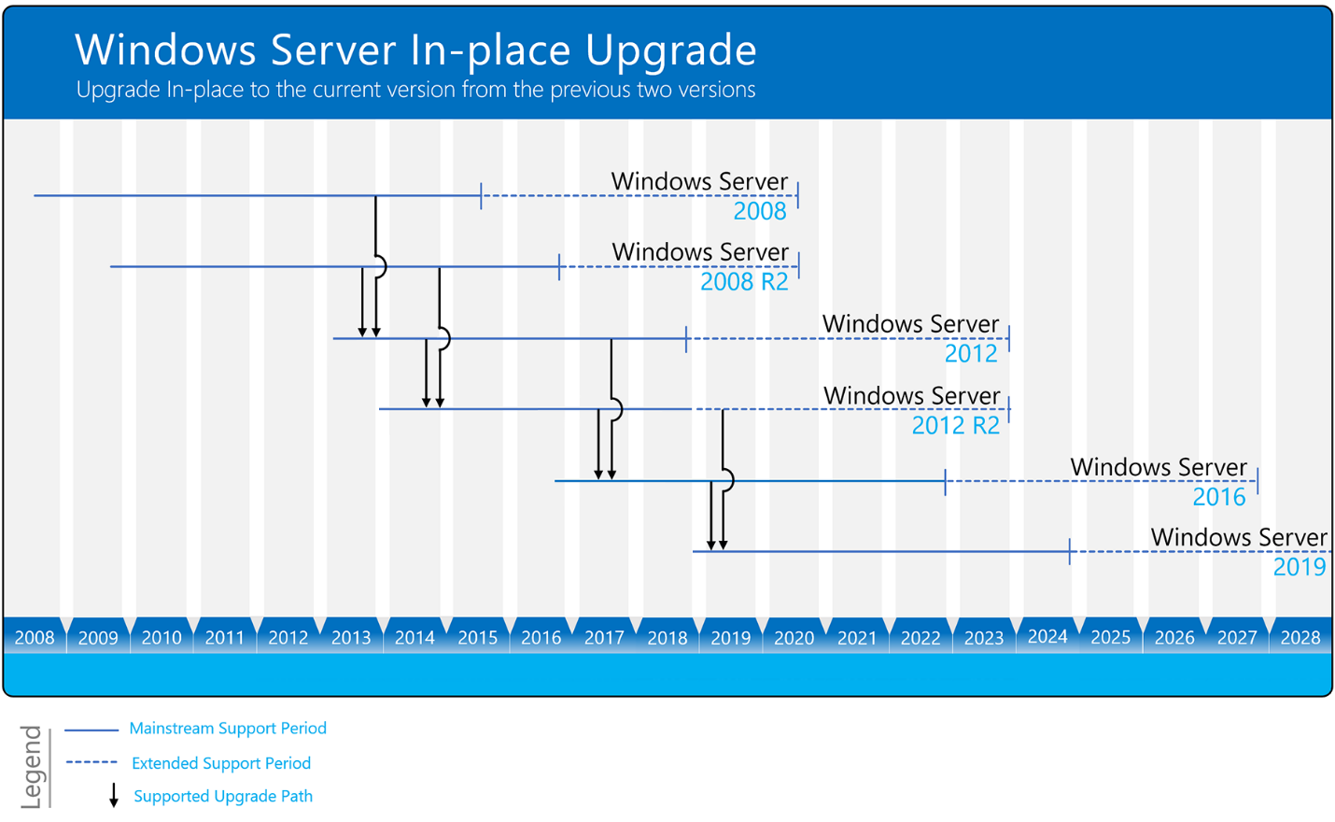

Windows Server can be typically be upgraded through at least one, and sometimes even two, versions. For example, Windows Server 2012 R2 and Windows Server 2016 can both be upgraded in-place to Windows Server 2019.